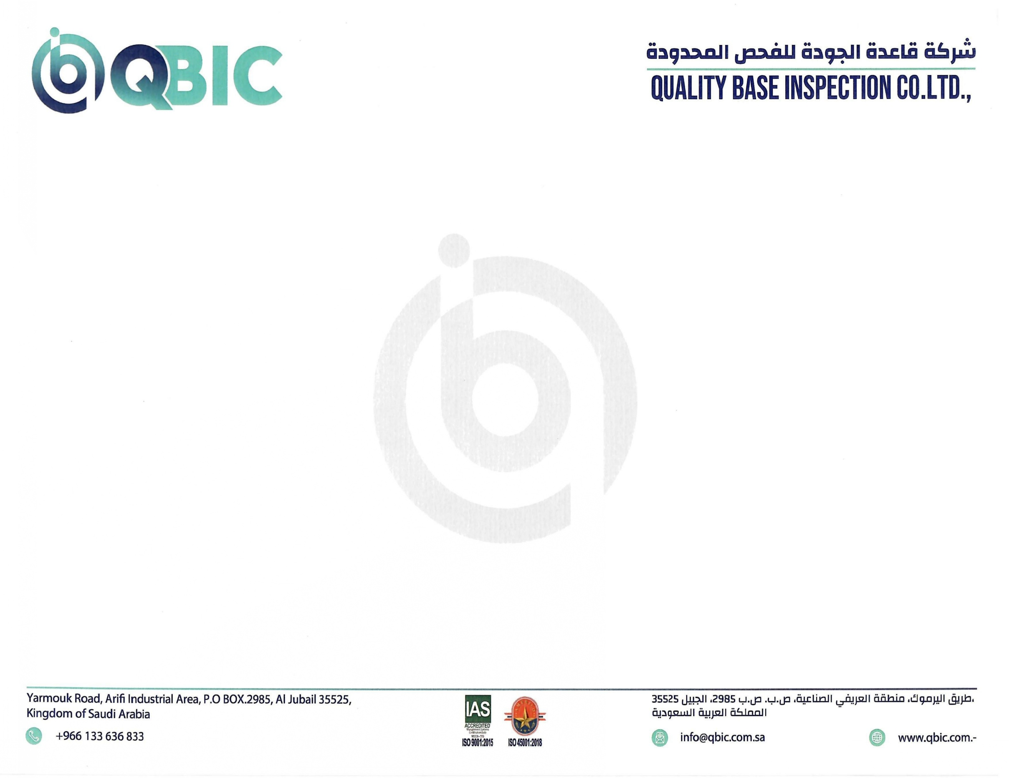

CERTIFICATE OF THOROUGH EXAMINATION OF WEBBING SLING
Certificate No.: | QBIC-2608-3437-11 | Job Order: | QBIC-JO26-686 | Report No: | 003093 | Date of Report: | 09/08/2026

Name & Address of the owner: |  | ALUCOR ARABIA. |  |  | Address of the inspection Location: | HAJAR – KINGDOM OF SAUDI ARABIA
Status: | ND = No Defect |  | Color Code:  (If required) | BLUE TILL SEP ONLY |  | Ref. Standard: | BS EN 1492-1:2000+A1:2008 / ASME B30.9
Status: | SDR = See Defect Report
Status: | NF = Not Found
Status: | OBS = Observation (see defect report)

S.No | SERIAL NO./TAG NO. | ITEM DESCRIPTION | MAKE | LENGTH  mtr | COLOUR CODE | WLL | DATE OF LAST THOROUGH EXAMINATION | DATE OF THIS THOROUGH EXAMINATION | DATE OF NEXT THOROUGH EXAMINATION | REASON FOR EXAMINATION | STATUS | SAFE TO USE  YES / NO
101 | 2521750427 | WEBBING SLING | TOHO | 2 M | GREEN | 2 TON | N/A | 09/08/2026 | 08/02/2027 | B | ND | YES
102 | 2521750493 | WEBBING SLING | TOHO | 2 M | GREEN | 2 TON | N/A | 09/08/2026 | 08/02/2027 | B | ND | YES
103 | 2521750140 | WEBBING SLING | TOHO | 2 M | GREEN | 2 TON | N/A | 09/08/2026 | 08/02/2027 | B | ND | YES
104 | 2521750515 | WEBBING SLING | TOHO | 2 M | GREEN | 2 TON | N/A | 09/08/2026 | 08/02/2027 | B | ND | YES
105 | 2521750486 | WEBBING SLING | TOHO | 2 M | GREEN | 2 TON | N/A | 09/08/2026 | 08/02/2027 | B | ND | YES
106 | 2521750142 | WEBBING SLING | TOHO | 2 M | GREEN | 2 TON | N/A | 09/08/2026 | 08/02/2027 | B | ND | YES
107 | 2521750370 | WEBBING SLING | TOHO | 2 M | GREEN | 2 TON | N/A | 09/08/2026 | 08/02/2027 | B | ND | YES
108 | 2521750405 | WEBBING SLING | TOHO | 2 M | GREEN | 2 TON | N/A | 09/08/2026 | 08/02/2027 | B | ND | YES
109 | 2521750499 | WEBBING SLING | TOHO | 2 M | GREEN | 2 TON | N/A | 09/08/2026 | 08/02/2027 | B | ND | YES
110 | 2521750396 | WEBBING SLING | TOHO | 2 M | GREEN | 2 TON | N/A | 09/08/2026 | 08/02/2027 | B | ND | YES

Reason for Examination: | INSTALLATION: A |  | 6 MONTHLY: B | 12 MONTHLY: C | WRITTEN SCHEME: D | EXCEPTIONAL CIRCUMSTANCE: E
INSPECTED BY: |  | SIGNATURE/STAMP: |  | APPROVED BY: |  | SIGNATURE:
FASEEH ULLAH  LEEA (FOU,LAC,MOB) |  |    |  | IRFAN MALIK BASHA |  |   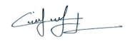
This certificate is granted subject to the condition that is understood and agreed that nothing herein contained shall be deemed to relieve any designer, manufacturer, seller, supplier, repairer or Operator of any warranty, express or implied, and Quality Base Inspection Company Ltd. Company liability shall be limited to the acts or omissions of its employees, agents and subcontractors. Under no circumstances shall Quality Base Inspection Company Ltd. be liable for any injury or damage to any person or occurring because of negligent operation or any defect in materials, machinery, equipment or other items other than such defects ascertainable by normally accepted standards and only those items inspected by Quality Base Inspection Company Ltd. Company and which are covered by this certificate

